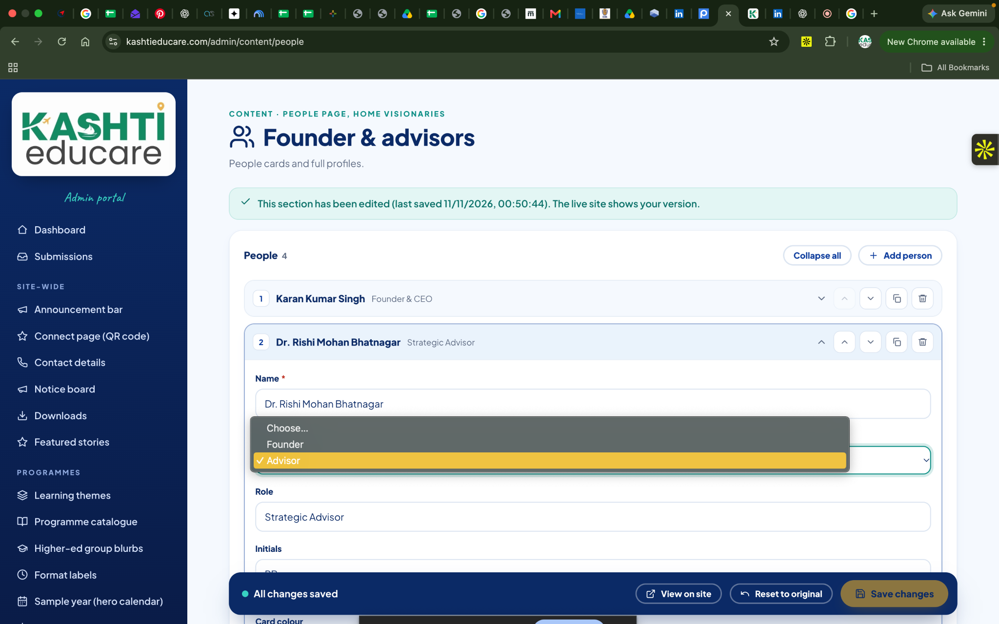1} REMOVE ADVISOR AND FOUNDER BIFURCATION
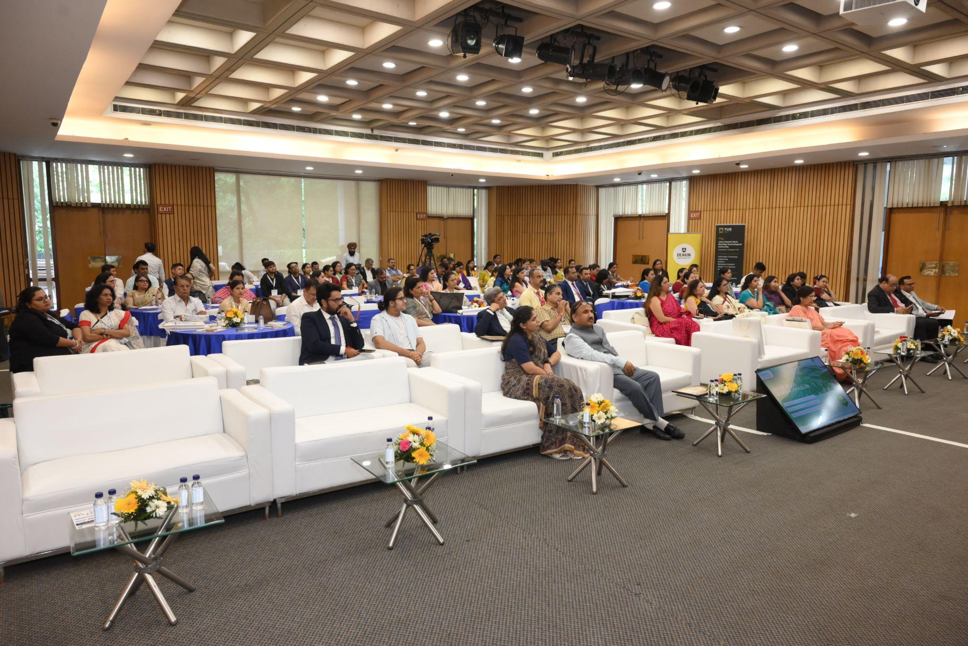2} PROGRAM PAGE 3 IMAGES TO BE UPLOADED | TAKE REF OF 3 IMAGES UPLOADED IN THE BELOW LINK
https://drive.google.com/drive/folders/1FfD-XcXWDBnEo-Jen4I20OJcehWtoRyJ?usp=drive_link
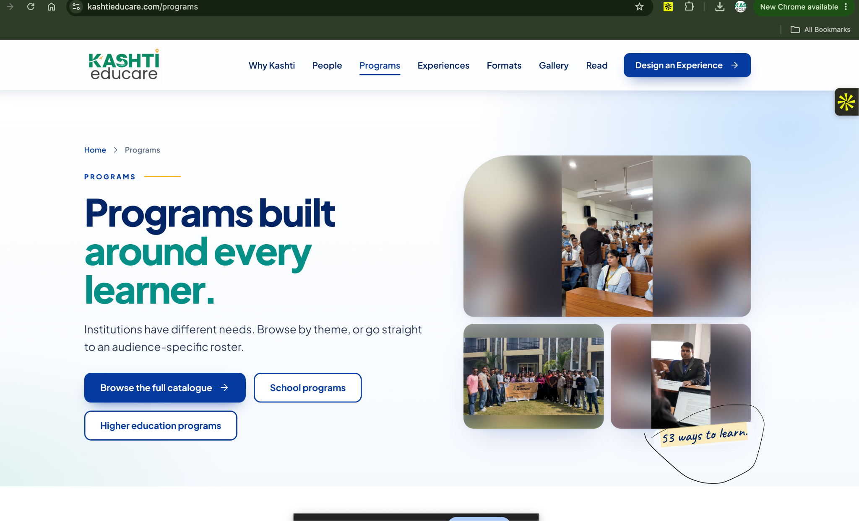
3} No cursive writing/remove 53 ways to learn
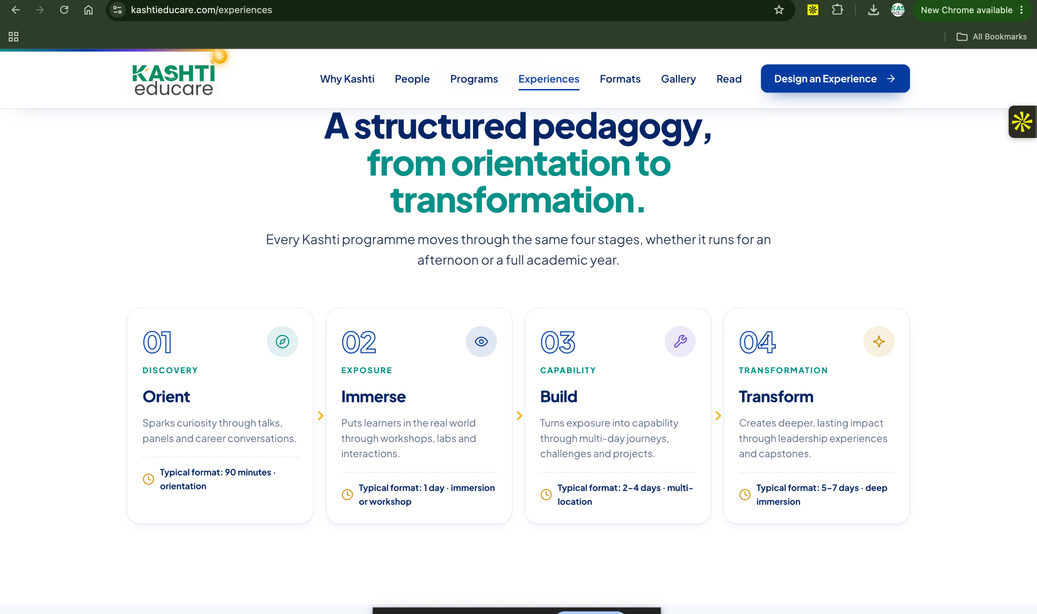
4} REMOVE THE SEGMENT MENTIONED IN THE SS
A STRUCTURED PEDAGOGY… ALL 4 ARE INCORRECT AND NOT REQUIRED, BECAUSE SEE BUILD BECOME LOGIC IS MENTIONED BELOW THIS IS CORRECT
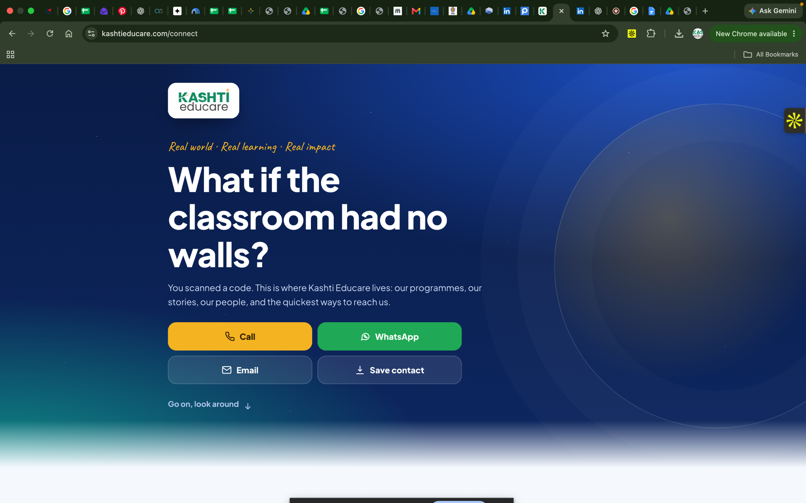
5} No cursive handwriting/looking AI made
6} Write “OUR ENGAGEMENTS” instead of Our partners and collaborators

